**DAILY ONLINE ACTIVITIES SUMMARY**

|  |  |  |  |  |  |  |  |  |
| --- | --- | --- | --- | --- | --- | --- | --- | --- |
| **Date:** | **14-07-2020** | | | | | **Name:** | **Anix Jugal D’Cunha** | |
| **Sem & Sec** | **8 sem , A sec** | | | | | **USN:** | **4AL16CS013** | |
| **Online Test Summary** | | | | | | | | |
| **Subject** | | **Not Conducted** | | | | | | |
| **Max. Marks** | | **--** | | **Score** | | | **--** | |
| **Certification Course Summary** | | | | | | | | |
| **Course** | **Complete PHP OOP Concepts for Absolute Beginners + Projects** | | | | | | | |
| **Certificate Provider** | | | **Udemy** | | **Duration** | | | 10.5 hours |
| **Coding Challenges** | | | | | | | | |
| **Problem Statement:** Java Program To Print Hollow Mirrored Rhombus. | | | | | | | | |
| **Status: Competed** | | | | | | | | |
| **Uploaded the report in Github** | | | | | **yes** | | | |
| **If yes Repository name** | | | | | **alvas-education-foundation/dcunhaanixjugal** | | | |
| **Uploaded the report in slack** | | | | | **yes** | | | |

Online Test Details: (Attach the snapshot and briefly write the report for the same)

**Not Conducted**

Certification Course Details: (Attach the snapshot and briefly write the report for the same)

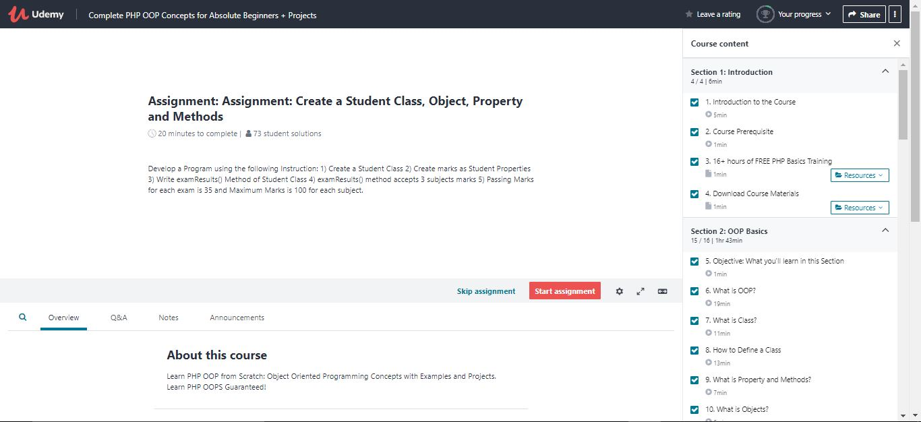

Coding Challenges Details: (Attach the snapshot and briefly write the report for the same)

## Program-> Java Program To Print Hollow Mirrored Rhombus.

|  |
| --- |
|  |

**public class HMRhombusstar**

**{**

**public static void main(String[] args)**

**{**

**Scanner sc=new Scanner(System.in);**

**System.out.println("Enter N : ");**

**int n=sc.nextInt();**

**System.out.print("Enter Symbol : ");**

**char c = sc.next().charAt(0);**

**int i=1,j=1;**

**do**

**{**

**j=i;**

**do**

**{**

**System.out.print(" ");**

**}**

**while(--j>0);**

**if(i==1 || i==n)**

**{**

**j=1;**

**do**

**{**

**System.out.print(c);**

**}**

**while(++j<=n);**

**}**

**else**

**{**

**j=1;**

**do**

**{**

**if(j==1 || j==n)**

**System.out.print(c);**

**else**

**System.out.print(" ");**

**}while(++j<=n);**

**}**

**System.out.println();**

**++i;**

**} while(i<=n);**

**}**

**}**